Price Comparison 2.0 Installation Guide

- Download J2SE 6.0 from Sun Micro Systems: http://java.sun.com/javase/downloads/index.jsp

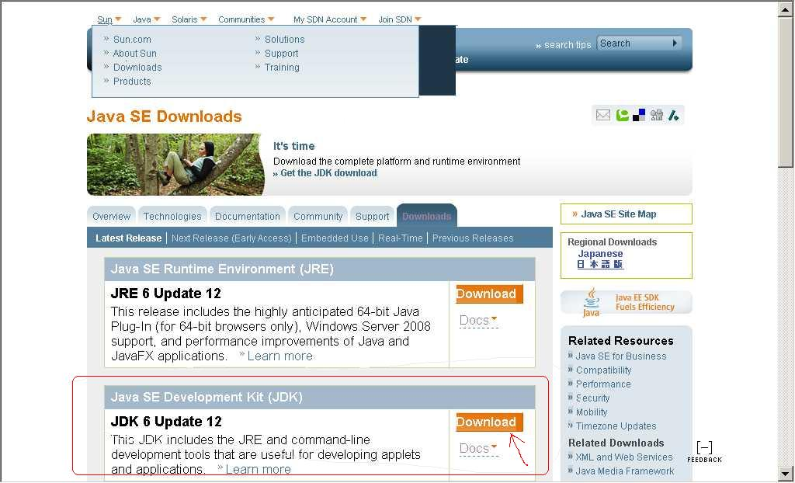

- Install jdk-6u12-windows-i586-p.exe (* vary based on the latest JDK version and your machine whether it’s 64bit or not) to your Windows
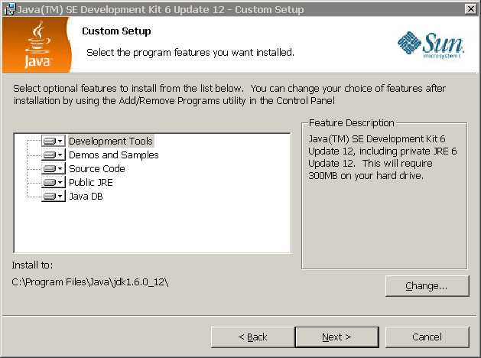

- Install “price-comparison-installer.jar” by double-click on that file
By default, the program will be installed to “c:\Program Files\PriceComaprison”

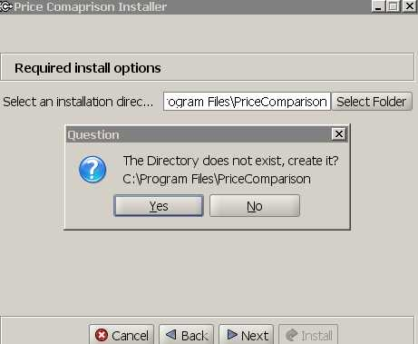

- To invoke the program, double click on “run-pricecomparison.bat”
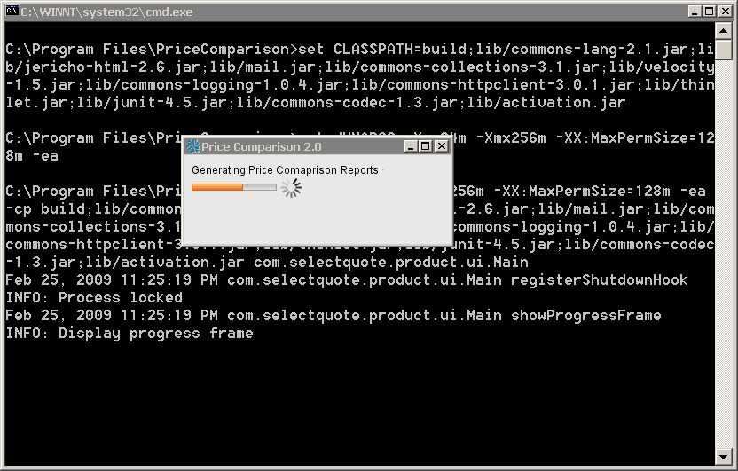
- You can minimize the progress bar while the reports are running. An email like the following will be delivered to your mailbox upon completion.

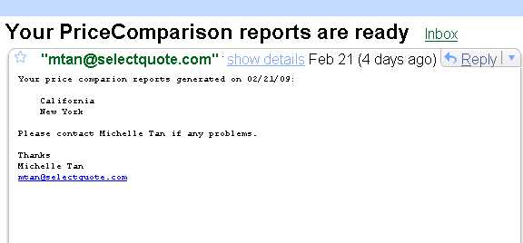

- Clicking on the report links(California or New York) will bring up the reports. Or you can find the reports under c:\Program Files\PriceComaprison\reports directory. If for whatever reasons we fail to generate the reports, Michelle will be notified automatically via an error email similar to this.

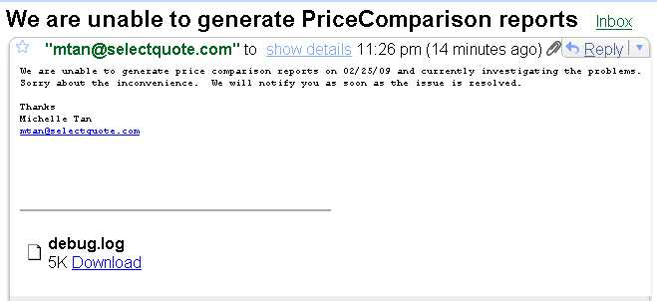

- Optionally, you can create a shortcut on your desktop: right click and select “Create Shortcut”, then move the shortcut to Desktop. You can even link an icon to the short cut by right click then select “Properties”
